Development of a National Cancer Strategy for 2016-2025

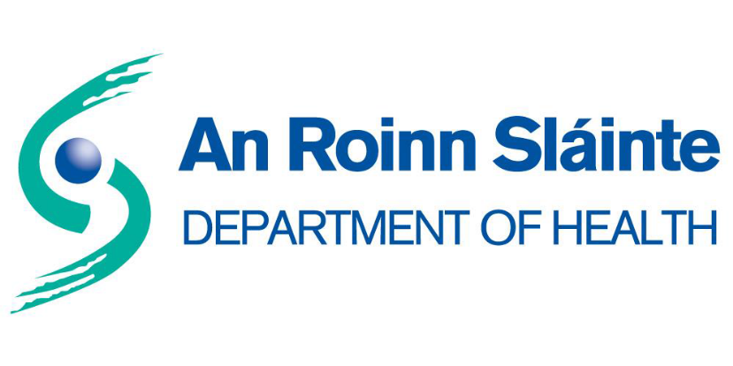

Public Consultation

19 June 2015 – 24 July 2015

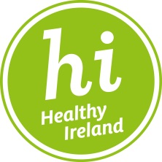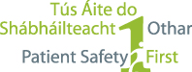
Background

The Minister for Health Leo Varadkar has announced that a new National Cancer Strategy is to be developed. This will be the third cancer strategy, covering the period 2016 to 2025.

A Cancer Strategy Steering Group has been established to advise the Department on the development of the Strategy. It is anticipated that the work of the Steering Group will be completed by the end of 2015, when it will make recommendations on a draft Strategy to the Minister. The implementation of a new strategy will commence in 2016.

(Further information is available at: http://health.gov.ie/blog/press-release/steering-group-to-develop-national-cancer-strategy-2016-2025).

Your Opinion Matters

The Department of Health is seeking the views of the public on cancer services and on priorities for a new cancer strategy. The public consultation will help the Department of Health and the Cancer Strategy Steering Group to focus on what is important, in order to deal with cancer in Ireland over the next 10 years.

The information from the public consultation will be analysed and the findings will be communicated to the Cancer Strategy Steering Group.

Everyone is welcome to respond to this consultation and we hope that patients and their families, the general public, carers, voluntary organisations, health and social care providers, health professionals and representative organisations will respond.

What you are being asked to do

You are invited to give your views on cancer services under the questions on pages 4-5.
We have chosen these headings to reflect some of the key priorities and policy questions for the development of the strategy.

You may provide input to some or all of the questions and your input will be limited to the space provided for each question. In addition, you may provide any additional views in the final box.

How to send your submission

The document may be submitted by e-mail or post to the following:

- E-mail: cancerconsultation@health.gov.ie

- Post: Cancer Strategy Public Consultation
Department of Health
Hawkins House
Hawkins Street
Dublin 2

Closing date: All submissions must be received by 5pm on Friday 24 July 2015.

Data Protection and Freedom of Information Acts 1997 and 2003

The information collected from the submissions made through this consultation process will be subject to the provisions of the Data Protection Act, 1988 and the Data Protection Amendment Act, 2003. Please note that all information and comments submitted to the Department of Health for the purpose of this consultation process are subject to release under the Freedom of Information Acts 1997 and 2003.

The Department intends to publish the names of parties who make submissions as part of this consultation process.

Your Details:

Name

Group/ Organisation

Address

Please indicate whether you consent to your name being published:

☐ Yes
☐ No

Please outline in what capacity you are submitting this document:

- Are you completing this document?

☐ In a personal capacity
☐ As an authorised representative expressing the views of an organisation/body

- If you are completing this survey as an authorised representative of an organisation/body, please state if that organisation/body is:

☐ Public Health Service Organisation / Provider ☐ Union
☐ Private Health Service Organisation / Provider ☐ Representative Body
☐ Regulatory Body ☐ Patient Interest Group
☐ Public Interest Group ☐ Other

- Have you had direct experience of cancer services (as a patient/family member/care giver, etc.)?

☐ Yes
☐ No

In the following areas, what do you think are the main strengths and weaknesses of current cancer services?

Strengths Weaknesses

Primary Care
(e.g. GP, public health / practice nurses)

Cancer Screening

Prevention

Early Diagnosis

Strengths Weaknesses

Palliative and Hospice Care

Support Services for Cancer Patients

Provision of Information

Hospital Services

Strengths Weaknesses

Research / Cancer Data

What are your top four priorities for a National Cancer Strategy for 2016-2025?
1.
3.
2.
4.

Any additional comments:

